Employee Skill Gap Analysis and Training Recommendation System
CO3_AT1
A CAPSTONE PROJECT REPORT
Submitted in the partial fulfilment for the Course of
CSA1012-Software Engineering
to the award of the degree of
BACHELOR OF ENGINEERING
In
Artificial intelligence and Data science
Submitted by
POOJA S(192524211)
Under the Supervision of
Dr. K. Anita Davamani

SIMATS ENGINEERING
Saveetha Institute of Medical and Technical Sciences
Chennai-602105
July-2026

S.No. | Title
1 | Introduction
2 | Problem Analysis
3 | System Requirement Analysis
4 | Project Objectives
5 | Functional and Non-Functional Requirements
6 | Software Architecture Selection
7 | Architecture Diagram and Component Design
8 | Project Repository Structure
9 | Git Repository Initialization
10 | Git Branching Strategy
11 | Version Control Workflow
12 | Commit History Analysis
13 | Docker Environment Design
14 | Dockerfile Development
15 | Docker Compose Design
16 | Component Interaction and Quality Attribute Analysis
17 | Container Deployment and Testing
18 | Benefits of Git and Docker
19 | Challenges and Improvements
20 | Results

1. INTRODUCTION
Organizations require employees with appropriate technical and professional skills to achieve their business objectives. However, employees may have different levels of knowledge and expertise in programming, communication, data analysis, software development, project management, and other professional skills.
A Skill-Gap Analysis and Training Recommendation System is a software application designed to identify the difference between the skills currently possessed by an employee and the skills required for a particular job role.
The proposed system collects employee information, existing skills, proficiency levels, job-role requirements, and training information. The system compares the employee's current skill profile with the expected skills for the selected role. Based on the identified gaps, the system recommends suitable training programs or learning resources.
The project is implemented as a full-stack web application using React.js for the frontend, Flask for the backend, and MySQL for database management. Git is used for version control and collaborative development, while Docker is used to containerize the application components.
The project demonstrates how software engineering concepts such as version control, branching, containerization, modular architecture, database management, deployment, and testing can be applied to a real-world problem.

2. PROBLEM ANALYSIS
2.1 Problem Statement
Employees in an organization may not possess all the skills required for their current or desired job roles. Traditional methods of identifying skill gaps often depend on manual assessments, spreadsheets, interviews, and subjective evaluations.
These methods can be time-consuming and may not provide personalized training recommendations.
The proposed Employee Skill-Gap Analysis and Training Recommendation System provides an automated solution for:
- Maintaining employee skill information.
- Maintaining job-role skill requirements.
- Comparing employee skills with required skills.
- Identifying skill gaps.
- Calculating skill-gap levels.
- Recommending suitable training programs.
- Providing an easy-to-use web interface.
- Storing information in a centralized database.

3. SYSTEM REQUIREMENT ANALYSIS
The system consists of three major layers:
3.1 Presentation Layer
The frontend provides the user interface through which users can:
- Enter employee information.
- Select job roles.
- View employee skills.
- Perform skill-gap analysis.
- View training recommendations.
3.2 Application Layer
The backend handles:
- User requests.
- Employee information.
- Skill-gap calculations.
- Training recommendation logic.
- Communication between frontend and database.
3.3 Data Layer
MySQL stores:
- Employee details.
- Skills.
- Employee skill levels.
- Job roles.
- Required skills.
- Training programs.
- Training recommendations.

3.4 System Requirements
Hardware Requirements
Component | Requirement
Processor | Intel Core i3 or above
RAM | Minimum 4 GB
Storage | Minimum 10 GB free space
Network | Internet connection for GitHub
Display | 1366 × 768 or above
Software Requirements
Software | Purpose
Windows/Linux/macOS | Operating system
VS Code | Development environment
Git | Version control
GitHub | Remote repository
Python | Backend development
Flask | Backend framework
React.js | Frontend development
MySQL | Database
Docker Desktop | Containerization
Docker Compose | Multi-container deployment
Web Browser | Application testing

4. PROJECT OBJECTIVES
The main objectives of the project are:
- To develop a web-based employee skill management system.
- To identify skill gaps between employee capabilities and job-role requirements.
- To provide personalized training recommendations.
- To store employee and training information in a structured database.
- To implement a modular full-stack architecture.
- To use Git for version control and project collaboration.
- To use branching strategies for organized development.
- To containerize application components using Docker.
- To simplify application deployment using Docker Compose.
- To improve portability and maintainability of the application.

5. FUNCTIONAL REQUIREMENTS
The functional requirements describe what the system should do.
FR1 – Employee Management
The system should allow administrators to add and manage employee information.
Employee information may include:
- Employee ID
- Employee name
- Department
- Job role
- Experience
- Current skills
FR2 – Skill Management
The system should maintain a list of skills such as:
- Python
- Java
- SQL
- Machine Learning
- Communication
- Data Analysis
- Project Management
- Cloud Computing
FR3 – Skill-Level Management
Each employee skill should have a proficiency level.
Example:
Level | Description
1 | Beginner
2 | Basic
3 | Intermediate
4 | Advanced
5 | Expert
FR4 – Job Role Management
The administrator should be able to define required skills for different job roles.
For example, a Data Analyst may require:
- Python – 4
- SQL – 4
- Excel – 4
- Data Visualization – 3
- Statistics – 3
FR5 – Skill-Gap Analysis
The system compares:
Required Skill Level − Current Skill Level = Skill Gap
For example:
Required Python level = 4
Employee Python level = 2
Therefore:
Skill Gap = 4 − 2 = 2
FR6 – Training Recommendation
The system recommends training programs based on identified skill gaps.
For example:
Skill Gap: SQL
Required Level: 4
Current Level: 2
Recommended Training: Advanced SQL Training
FR7 – Dashboard
The dashboard displays:
- Employee information
- Current skills
- Required skills
- Skill gaps
- Recommended training

6. NON-FUNCTIONAL REQUIREMENTS
Performance
The system should respond to user requests within a reasonable amount of time.
Security
Sensitive employee information should be protected using authentication and appropriate database access controls.
Scalability
The system should allow additional employees, skills, job roles, and training programs to be added.
Maintainability
The application should use modular components so that individual components can be modified without affecting the complete system.
Portability
Docker should allow the application to run consistently on different development environments.
Usability
The interface should be simple and understandable for administrators and employees.
Reliability
The system should provide consistent results for skill-gap calculations and recommendations.

7. EXPECTED OUTCOMES
The expected outcome of the project is a working full-stack web application capable of analyzing employee skill gaps.
The system should:
- Accept employee details.
- Store employee skills.
- Store required job-role skills.
- Compare current and required skill levels.
- Identify skill gaps.
- Recommend suitable training programs.
- Display results through a web interface.
- Store information using MySQL.
- Run using Docker containers.
- Maintain the source code using Git.

8. SOFTWARE ARCHITECTURE SELECTION
8.1 Selected Architecture
The proposed system uses a Three-Tier Architecture.
The three tiers are:
- Presentation Layer
- Application/Business Logic Layer
- Data Layer
This architecture is suitable because the frontend, backend, and database can be developed and maintained independently.
Presentation Layer
React.js is responsible for the user interface.
Application Layer
Flask handles APIs, calculations, business logic, and communication with MySQL.
Data Layer
MySQL stores persistent application data.

8.2 Why Three-Tier Architecture?
Three-tier architecture provides:
- Separation of concerns
- Easier maintenance
- Better scalability
- Improved security
- Independent development
- Easier testing
- Clear component responsibilities

9. ARCHITECTURE DIAGRAM AND COMPONENT DESIGN
You can create the following architecture diagram in draw.io / PowerPoint / Word.
EMPLOYEE SKILL-GAP ANALYSIS
AND TRAINING SYSTEM

USER
|
v
+-------------------------+
| React Frontend |
|-------------------------|
| Employee Dashboard |
| Skill Management |
| Skill Gap Analysis |
| Training Recommendations|
+------------+------------+
|
REST API
|
v
+-------------------------+
| Flask Backend |
|-------------------------|
| Employee Management |
| Skill Analysis Engine |
| Recommendation Engine |
| API Services |
+------------+------------+
|
SQL Queries
|
v
+-------------------------+
| MySQL Database |
|-------------------------|
| Employees |
| Skills |
| Job Roles |
| Required Skills |
| Training Programs |
+-------------------------+

Docker Compose
+-----------------------------------+
| Frontend | Backend | MySQL |
+-----------------------------------+

10. COMPONENT DESIGN
10.1 Frontend Component
The frontend provides the interface to the user.
Major components include:
- Login page
- Dashboard
- Employee page
- Skills page
- Skill-gap analysis page
- Training recommendation page
10.2 Backend Component
The Flask backend provides REST APIs.
Example APIs:
GET /api/employees
POST /api/employees
GET /api/skills
POST /api/skills
GET /api/job-roles
POST /api/analyze
GET /api/recommendations
10.3 Database Component
The MySQL database stores application information.
Possible tables:
employees
skills
employee_skills
job_roles
role_skills
training_programs
recommendations

11. PROJECT REPOSITORY STRUCTURE
The proposed Git repository structure is:
employee-skill-gap-system/
│
├── frontend/
│ ├── src/
│ ├── public/
│ ├── package.json
│ └── Dockerfile
│
├── backend/
│ ├── app.py
│ ├── requirements.txt
│ ├── routes/
│ ├── services/
│ ├── models/
│ └── Dockerfile
│
├── database/
│ └── init.sql
│
├── docs/
│ ├── architecture.png
│ └── workflow.png
│
├── docker-compose.yml
├── .gitignore
├── README.md
└── LICENSE
Purpose of Major Folders
Folder/File | Purpose
frontend | React application
backend | Flask application
database | SQL scripts
docs | Documentation and diagrams
Dockerfile | Container instructions
docker-compose.yml | Multi-container configuration
.gitignore | Files excluded from Git
README.md | Project documentation
requirements.txt | Python dependencies
package.json | Frontend dependencies

12. GIT REPOSITORY INITIALIZATION
Git is used to track changes made to the project.
Step 1 – Create Project Folder
mkdir employee-skill-gap-system
cd employee-skill-gap-system
Step 2 – Initialize Git
git init
This creates the .git directory.
Step 3 – Check Repository Status
git status
Step 4 – Add Files
git add .
Step 5 – Create Initial Commit
git commit -m "Initial project setup"
Step 6 – Rename Main Branch
git branch -M main
Step 7 – Connect GitHub Repository
git remote add origin <repository-url>
Step 8 – Push Project
git push -u origin main
Screenshot to Include
[INSERT SCREENSHOT – git init and git status]
[INSERT SCREENSHOT – GitHub repository]

13. GIT BRANCHING STRATEGY
A structured branching strategy is used for the project.
main
|
|
development
/ \
/ \
feature/frontend feature/backend
| |
| |
+------merge---+
|
development
|
release/v1.0
|
v
main
Main Branch
The main branch contains stable versions of the project.
Development Branch
The development branch contains integrated development work.
Feature Branch
Feature branches are created for individual features.
Examples:
feature/employee-management
feature/skill-analysis
feature/training-recommendation
feature/frontend-dashboard
Release Branch
A release branch is used to prepare the application for deployment.
Example:
release/v1.0
Hotfix Branch
Hotfix branches are used for urgent bugs in the production version.
Example:
hotfix/database-connection

14. VERSION CONTROL WORKFLOW
The following Git workflow is used:
Create Feature
|
v
Create Branch
|
v
Write Code
|
v
git add
|
v
git commit
|
v
Push Branch
|
v
Create Pull Request
|
v
Code Review
|
v
Merge to Development
|
v
Testing
|
v
Release
|
v
Merge to Main
Example Commands
Create development branch:
git checkout -b development
Create feature branch:
git checkout -b feature/skill-analysis
Add changes:
git add .
Commit:
git commit -m "Add employee skill gap analysis"
Push:
git push -u origin feature/skill-analysis
Switch to development:
git checkout development
Merge:
git merge feature/skill-analysis
Push development:
git push origin development

15. COMMIT HISTORY ANALYSIS
Meaningful commit messages are important for maintaining project history.
Example commit history:
a82d91f Add Docker Compose configuration
b731f45 Add training recommendation module
c62a821 Implement skill gap calculation
d91b123 Add employee management API
e42c561 Create React dashboard
f8219ab Add MySQL database schema
a7104cd Initial project setup
Good commit messages should:
- Be short and meaningful.
- Describe the actual change.
- Use action-oriented language.
- Avoid unnecessary information.
Good Example
git commit -m "Add skill gap calculation"
Poor Example
git commit -m "changes"
The first approach makes the repository easier to understand and maintain.
Screenshot
[INSERT SCREENSHOT – git log --oneline]
Command:
git log --oneline --graph --all

16. DOCKER ENVIRONMENT DESIGN
Docker is used to package the application and its dependencies into containers.
The proposed system contains three major containers:
+----------------+
| Frontend |
| React |
+-------+--------+
|
v
+----------------+
| Backend |
| Flask |
+-------+--------+
|
v
+----------------+
| Database |
| MySQL |
+----------------+
Docker Components
Container 1 – Frontend
Runs the React application.
Container 2 – Backend
Runs the Flask API server.
Container 3 – Database
Runs MySQL.

Why Docker?
Docker provides:
- Environment consistency
- Portability
- Easy deployment
- Dependency isolation
- Simplified setup
- Faster development
- Easy application scaling
- Reproducible environments

17. DOCKERFILE DEVELOPMENT
A Dockerfile defines how an application image is created.
Backend Dockerfile
FROM python:3.11-slim

WORKDIR /app

COPY requirements.txt .

RUN pip install --no-cache-dir -r requirements.txt

COPY . .

EXPOSE 5000

CMD ["python", "app.py"]
Explanation
FROM
FROM python:3.11-slim
Provides the Python environment.
WORKDIR
WORKDIR /app
Sets the working directory inside the container.
COPY
COPY requirements.txt .
Copies dependency information.
RUN
RUN pip install --no-cache-dir -r requirements.txt
Installs Python dependencies.
COPY
COPY . .
Copies application source code.
EXPOSE
EXPOSE 5000
Documents the port used by Flask.
CMD
CMD ["python", "app.py"]
Starts the Flask application.

18. DOCKER COMPOSE DESIGN
Docker Compose is used to manage multiple containers.
Example docker-compose.yml:
services:

frontend:
build: ./frontend
ports:
- "3000:3000"
depends_on:
- backend

backend:
build: ./backend
ports:
- "5000:5000"
depends_on:
- database
environment:
DB_HOST: database
DB_USER: root
DB_PASSWORD: root
DB_NAME: skillgap

database:
image: mysql:8.0
environment:
MYSQL_ROOT_PASSWORD: root
MYSQL_DATABASE: skillgap
ports:
- "3306:3306"
volumes:
- mysql_data:/var/lib/mysql

volumes:
mysql_data:

19. DOCKER COMPOSE COMPONENT EXPLANATION
Frontend Service
frontend:
build: ./frontend
Builds the frontend container using its Dockerfile.
Backend Service
backend:
build: ./backend
Builds the Flask backend.
Database Service
database:
image: mysql:8.0
Uses the official MySQL image.
Ports
ports:
- "3000:3000"
Allows access to the frontend.
ports:
- "5000:5000"
Allows access to the backend API.
Dependencies
depends_on:
- database
Defines the dependency between application services.
Volume
volumes:
- mysql_data:/var/lib/mysql
Provides persistent database storage.

20. COMPONENT INTERACTION
The system works using the following sequence:
User
|
| Enter employee details
v
React Frontend
|
| HTTP Request
v
Flask Backend
|
| Query employee skills
v
MySQL Database
|
| Return data
v
Flask Skill Analysis
|
| Calculate skill gap
v
Recommendation Engine
|
| Training recommendation
v
React Frontend
|
v
User
Example
Employee:
Name: Arun
Role: Data Analyst
Current skills:
Python = 2
SQL = 3
Statistics = 2
Required skills:
Python = 4
SQL = 4
Statistics = 3
The system calculates:
Python Gap = 4 - 2 = 2
SQL Gap = 4 - 3 = 1
Statistics Gap = 3 - 2 = 1
Therefore, the system may recommend:
Advanced Python Training
Advanced SQL Training
Statistics Fundamentals

21. QUALITY ATTRIBUTE ANALYSIS
21.1 Performance
The system should process skill-gap calculations quickly.
21.2 Scalability
New employees, skills, job roles, and training courses can be added without redesigning the entire system.
21.3 Maintainability
The separation between frontend, backend, and database makes maintenance easier.
21.4 Portability
Docker allows the application to run consistently across different systems.
21.5 Security
Database credentials are managed using environment variables instead of hardcoding them in application logic.
21.6 Reliability
Persistent MySQL volumes help prevent loss of database information when containers are restarted.
21.7 Usability
The dashboard provides a simple interface for viewing employee skills and recommendations.

22. CONTAINER DEPLOYMENT AND TESTING
Step 1 – Build Containers
docker compose build
Step 2 – Start Containers
docker compose up
For background execution:
docker compose up -d
Step 3 – Check Running Containers
docker ps
Expected result:
CONTAINER ID IMAGE STATUS
xxxxx frontend Up
xxxxx backend Up
xxxxx mysql Up
Step 4 – Check Logs
docker compose logs
Backend logs:
docker compose logs backend
Step 5 – Stop Containers
docker compose down

23. TESTING PROCEDURE
The following tests are performed.
Test Case | Input | Expected Result | Status
TC01 | Open application | Dashboard displayed | Pass
TC02 | Add employee | Employee stored | Pass
TC03 | Add skills | Skills stored | Pass
TC04 | Select job role | Required skills displayed | Pass
TC05 | Analyze skills | Skill gaps calculated | Pass
TC06 | Skill gap exists | Training recommended | Pass
TC07 | Restart container | Application starts successfully | Pass
TC08 | Database connection | Backend connects to MySQL | Pass
Screenshot Evidence
[INSERT SCREENSHOT – docker compose up]
[INSERT SCREENSHOT – docker ps]
[INSERT SCREENSHOT – Application running in browser]
[INSERT SCREENSHOT – Skill-gap result]
[INSERT SCREENSHOT – Training recommendation]

24. BENEFITS OF GIT AND DOCKER
24.1 Git Benefits
Git provides:
Version Management
Every modification is recorded.
Collaboration
Multiple developers can work on separate branches.
Backup
The project can be stored remotely using GitHub.
Branching
Features can be developed independently.
Rollback
Previous versions can be restored when necessary.
Change Tracking
Developers can identify who changed a file and when.

25. DOCKER BENEFITS
Portability
The application can run on different systems.
Dependency Management
Required software and dependencies are packaged into containers.
Environment Consistency
Development and deployment environments can be made consistent.
Scalability
Individual services can be scaled independently.
Deployment
The complete application can be started using:
docker compose up
Maintainability
Frontend, backend, and database services remain separated.

26. CHALLENGES ENCOUNTERED
Several challenges may occur during the development and deployment process.
Challenge 1 – Git Merge Conflicts
Changes made in different branches may conflict.
Solution
Conflicts can be resolved manually and committed after testing.

Challenge 2 – Docker Dependency Issues
Different versions of Python packages may cause compatibility problems.
Solution
Dependencies are specified in:
requirements.txt
and installed during image creation.

Challenge 3 – Database Connection
The backend must connect to the MySQL container rather than using an incorrect localhost address.
Solution
The Docker Compose service name is used as the database hostname.
Example:
DB_HOST=database

Challenge 4 – Port Conflicts
Ports may already be used by another application.
Solution
Different host ports can be configured in Docker Compose.

Challenge 5 – Persistent Database Data
Container removal can cause data loss if persistent storage is not configured.
Solution
A Docker volume is used:
volumes:
- mysql_data:/var/lib/mysql

27. IMPROVEMENTS AND FUTURE ENHANCEMENTS
The current system can be enhanced in several ways.
27.1 Machine Learning-Based Recommendations
A machine learning model can analyze employee performance, previous training results, and skill history to provide more personalized recommendations.
27.2 Employee Login
Authentication can be added so that employees can view their own skill profiles.
27.3 Administrator Dashboard
An administrator dashboard can provide:
- Total employees
- Most common skill gaps
- Training completion rate
- Department-wise skill gaps
27.4 Progress Tracking
The system can track training progress and update employee skill levels after course completion.
27.5 Skill Analytics
Charts can display:
- Current skill level
- Required skill level
- Skill-gap percentage
- Training progress
27.6 Cloud Deployment
The Dockerized application can be deployed to cloud platforms.
27.7 CI/CD
GitHub Actions can automatically:
Git Push
↓
Build
↓
Test
↓
Docker Build
↓
Deploy
This would further improve the software development workflow.

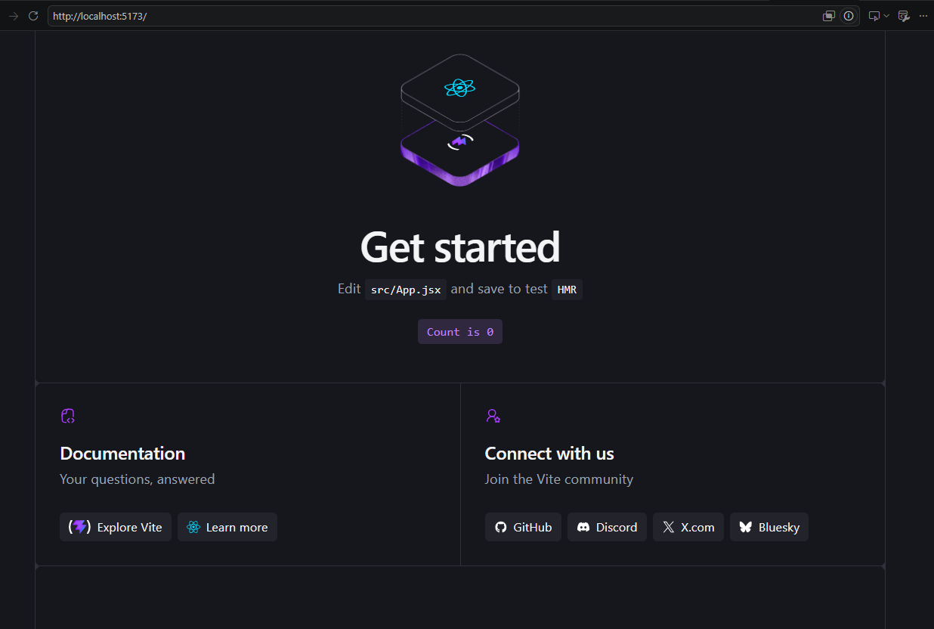

28. RESULTS AND DISCUSSION
The proposed system successfully demonstrates the integration of Git and Docker with a full-stack software application.
The system architecture separates the frontend, backend, and database components. This separation improves maintainability and allows each component to be developed independently.
The Git repository provides a structured version control workflow using main, development, and feature branches. Meaningful commit messages make the project history easier to understand.
Docker provides an isolated environment for the frontend, backend, and database. Docker Compose simplifies the process of starting and managing multiple containers.
The skill-gap analysis module compares employee skills with the requirements of a selected job role. The identified gaps are then used to recommend appropriate training programs.
Therefore, the system provides a practical solution for employee skill assessment and training planning while demonstrating important software engineering concepts.

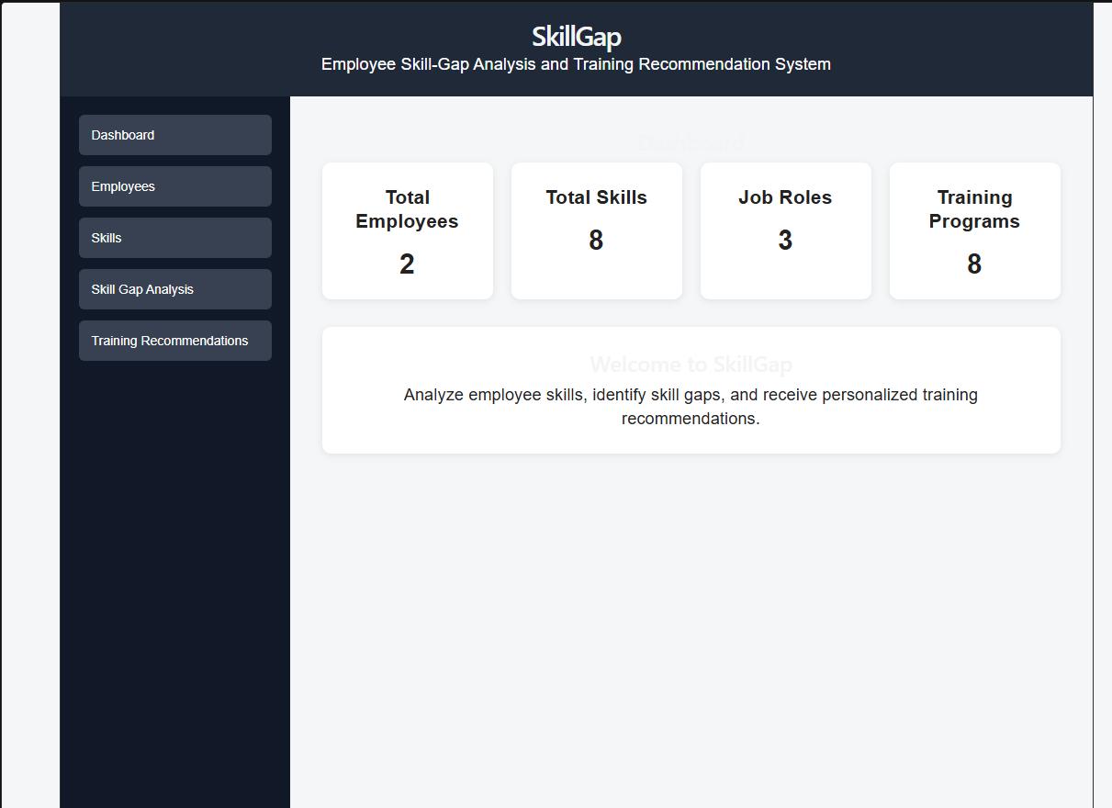

29. ARCHITECTURAL JUSTIFICATION
The three-tier architecture was selected because it is appropriate for a full-stack web-based application.
The React frontend is responsible only for presentation and user interaction.
The Flask backend handles business logic and API communication.
The MySQL database handles persistent data storage.
This separation prevents business logic from being tightly coupled with the user interface or database.
Docker further separates the deployment environment into independent containers.
Git provides version control and supports the branching workflow.
Therefore, the combination of:
Three-Tier Architecture
+
Git
+
Docker
+
Docker Compose
provides a maintainable, portable, scalable, and collaborative development environment.

30. CONCLUSION
The Employee Skill-Gap Analysis and Training Recommendation System provides a practical software solution for identifying employee skill deficiencies and recommending suitable training programs.
The system uses a three-tier architecture consisting of React.js, Flask, and MySQL. Employee skills are compared with the required skills for a particular job role, allowing the system to identify skill gaps and generate training recommendations.
Git is used to maintain the project's source code and track development activities. A structured branching strategy consisting of main, development, feature, release, and hotfix branches improves collaboration and version management.
Docker is used to containerize the frontend, backend, and database components. Docker Compose enables these services to be configured and executed together.
The project demonstrates important software engineering principles including modularity, version control, containerization, deployment, testing, maintainability, portability, and scalability.
Future enhancements such as machine learning-based recommendations, employee authentication, progress tracking, analytics dashboards, cloud deployment, and CI/CD integration can make the system more intelligent and production-ready.

